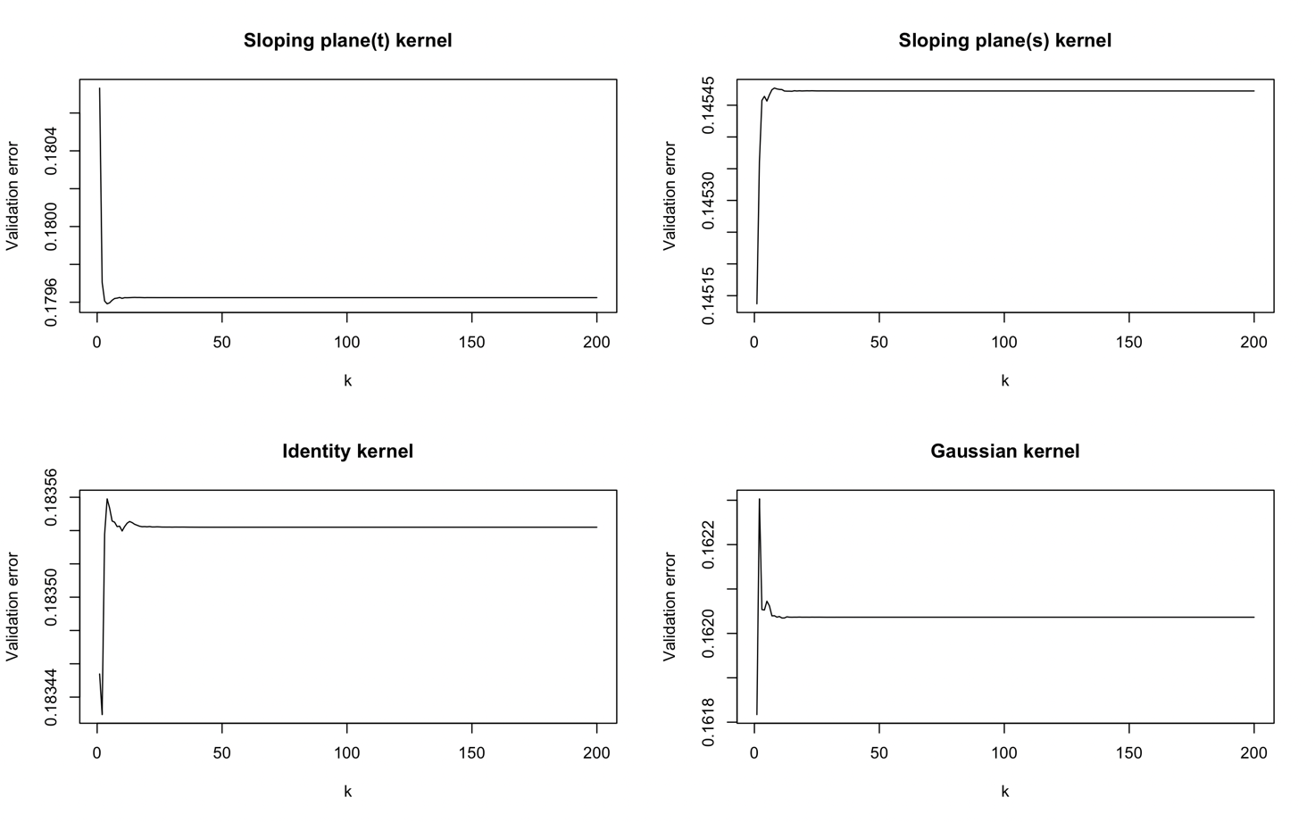

Test conducted for alpha = 0.75, constant of the kernel chosen such that their L2 norm is 0.5

* Sloping plane (t): k = 4
* Sloping plane (s): k = 1
* Identity: k = 2
* Gaussian: k = 1

Inserire una condizione che blocchi la CV sui k dopo che l’aggiunta di una PPC non apporta ulteriore potere esplicativo ⬄ se la differenza fra due validation errors consecutivi è minore di una tolleranza (10^-4(valore a cui è stat fissata), per far si che sia fattibile runnarlo per tante osservazioni della funzione: una run su un dataset 200x100, con 21 valori di alpha (dovendo quindi controllare alla peggio 21x200 parametri) dura all’incirca 1.9 minuti, mentre già con 10^-6 andava oltre i 7 minuti e mezzo per una singola run).

Se alpha è tanto grande (> 10^3): il primo autovalore di phi è tanto più dominante? Sembra di sì, perché controlla meno componenti

Riproduzione Didericksen, Kokoszka, Zhang in https://github.com/AndreaEnricoFranzoni/PPCforAutoregressiveOperator

Kernel: sloping plane t, sloping plane s, identity, gaussian

Norm kernel: 0.5, 0.8

Error: Brownian bridges

|  |  |  |  |  |  |  |
| --- | --- | --- | --- | --- | --- | --- |
| En (N=100, norm=0.5) | MP | NP | EX | EK (p=3) | EKI (p=3) | PF (CV) |
| Gaussian | 0.3955597  (0.02471538) | 0.646747  (0.03799152) | 0.3821823  (0.0218771) | 0.3955597  (0.02471538) | 0.3955597  (0.02471538) | 0.392858  (0.02394796) |
| Identity | 0.3979618  (0.02505296) | 0.6578705  (0.03850466) | 0.3819102  (0.02187437) | 0.3979618  (0.02505296) | 0.3979618  (0.02505296) | 0.393689  (0.02427105) |
| Sp t | 0.4017363  (0.02406165) | 0.6847887  (0.03897151) | 0.3813144  (0.02188474) | 0.4017362  (0.02406165) | 0.4017362  (0.02406165) | 0.3918411  (0.0241065) |
| Sp s | 0.3935745  (0.02554763) | 0.7052357  (0.0410395) | 0.3816438  (0.02193279) | 0.3935745  (0.02554763) | 0.3935745  (0.02554763) | 0.3995135  (0.02512163) |
| Rn (N=100, norm=0.5) |  |  |  |  |  |  |
| Gaussian | 0.3370337  (0.02355139) | 0.5452699  (0.03297587) | 0.3192063  (0.0201706) | 0.3370336  (0.02355139) | 0.3370337  (0.02355139) | 0.3284523  (0.0217308) |
| Identity | 0.3393995  (0.02366711) | 0.5556017  (0.03343659) | 0.3197431  (0.02016411) | 0.3393994  (0.02366711) | 0.3393994  (0.02366711) | 0.3283908  (0.02196682) |
| Sp t | 0.340542  (0.02243977) | 0.5804332  (0.03397701) | 0.319268  (0.02011736) | 0.340542  (0.02243976) | 0.340542  (0.02243977) | 0.3263704  (0.02195519) |
| Sp s | 0.336552  (0.02381141) | 0.5983886  (0.03607265) | 0.3194396  (0.02016857) | 0.336552  (0.02381141) | 0.336552  (0.02381141) | 0.3353644  (0.023089) |

|  |  |  |  |  |  |  |
| --- | --- | --- | --- | --- | --- | --- |
| En (N=100, norm=0.8) | MP | NP | EX | EK (p=3) | EKI (p=3) | PF (CV) |
| Gaussian | 0.4772431  ( 0.0275126) | 0.6589964  ( 0.03486477) | 0.3968116  ( 0.02282563) | 0.4772429  ( 0.02751259) | 0.477243  ( 0.02751259) | 0.4007304  ( 0.02242923) |
| Identity | 0.4812141  (0.02742814) | 0.671115  (0.03571326) | 0.394404  (0.02262079) | 0.481214  (0.02742813) | 0.481214  (0.02742813) | 0.4005297  (0.02269768) |
| Sp t | 0.4673803  (0.02576134) | 0.6833633  (0.03471741) | 0.3856748  (0.02187573) | 0.4673802  (0.02576133) | 0.4673802  (0.02576133) | 0.3970542  (0.02425861) |
| Sp s | 0.441569  (0.02727313) | 0.6809973  (0.03911723) | 0.383031  (0.02187021) | 0.4415689  (0.02727313) | 0.4415689  (0.02727313) | 0.3978593  (0.02413507) |
| Rn (N=100, norm=0.8) |  |  |  |  |  |  |
| Gaussian | 0.4187621  ( 0.02734486) | 0.5605876  ( 0.03051183) | 0.3341846  ( 0.02152874) | 0.418762  ( 0.02734485) | 0.418762  ( 0.02734485) | 0.3355301  ( 0.02001735) |
| Identity | 0.4227597  (0.02740684) | 0.5732181  (0.03132263) | 0.3317176  (0.02136127) | 0.4227596  (0.02740683) | 0.4227596  (0.02740683) | 0.3367019  (0.02032015) |
| Sp t | 0.4001364  (0.02440542) | 0.577752  (0.03114588) | 0.3230368  (0.02028865) | 0.4001363  (0.02440541) | 0.4001363  (0.02440542) | 0.3322337  (0.02212678) |
| Sp s | 0.3845084  (0.02657616) | 0.5812044  (0.03438699) | 0.3198201  (0.02024285) | 0.3845083  (0.02657615) | 0.3845083  (0.02657615) | 0.3342546  (0.02183971) |

* N = 100, sloping plane t

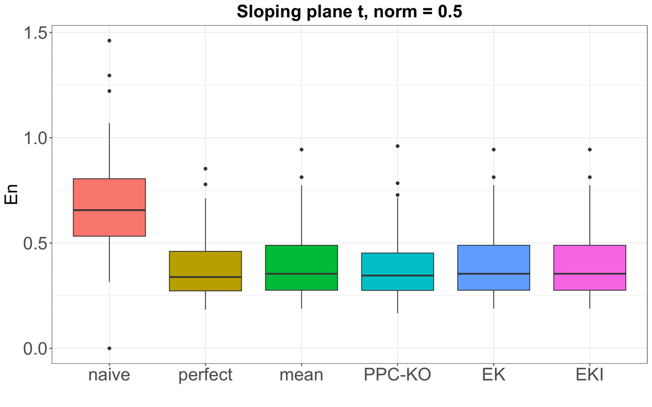

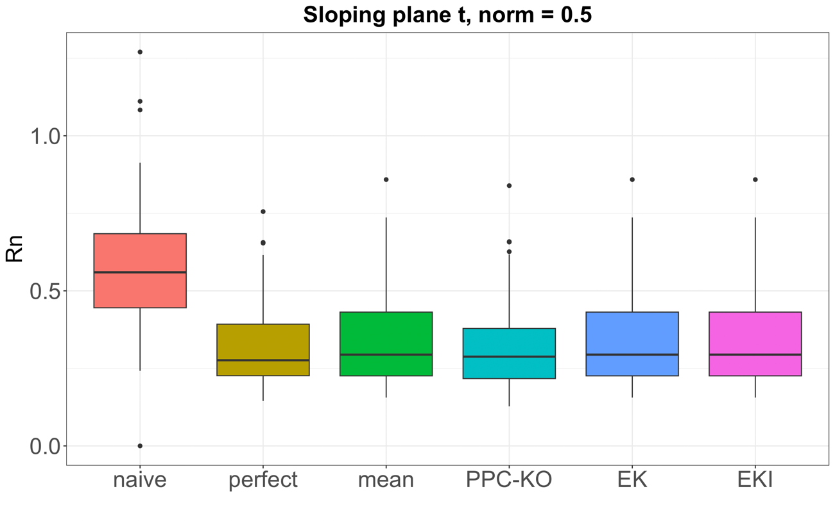

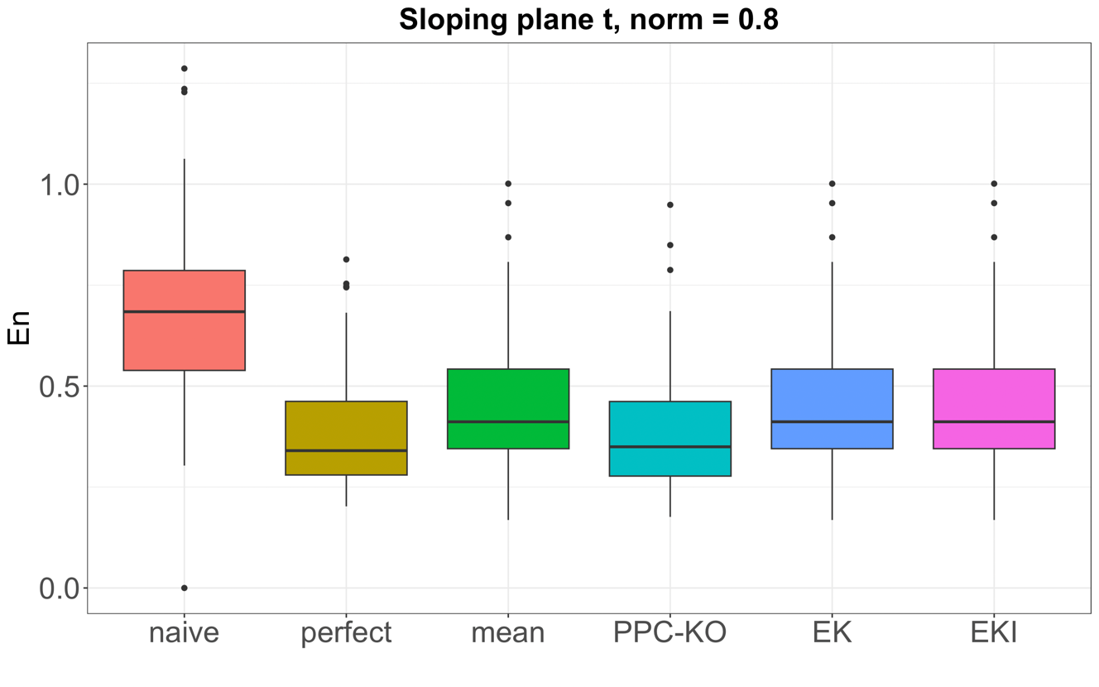

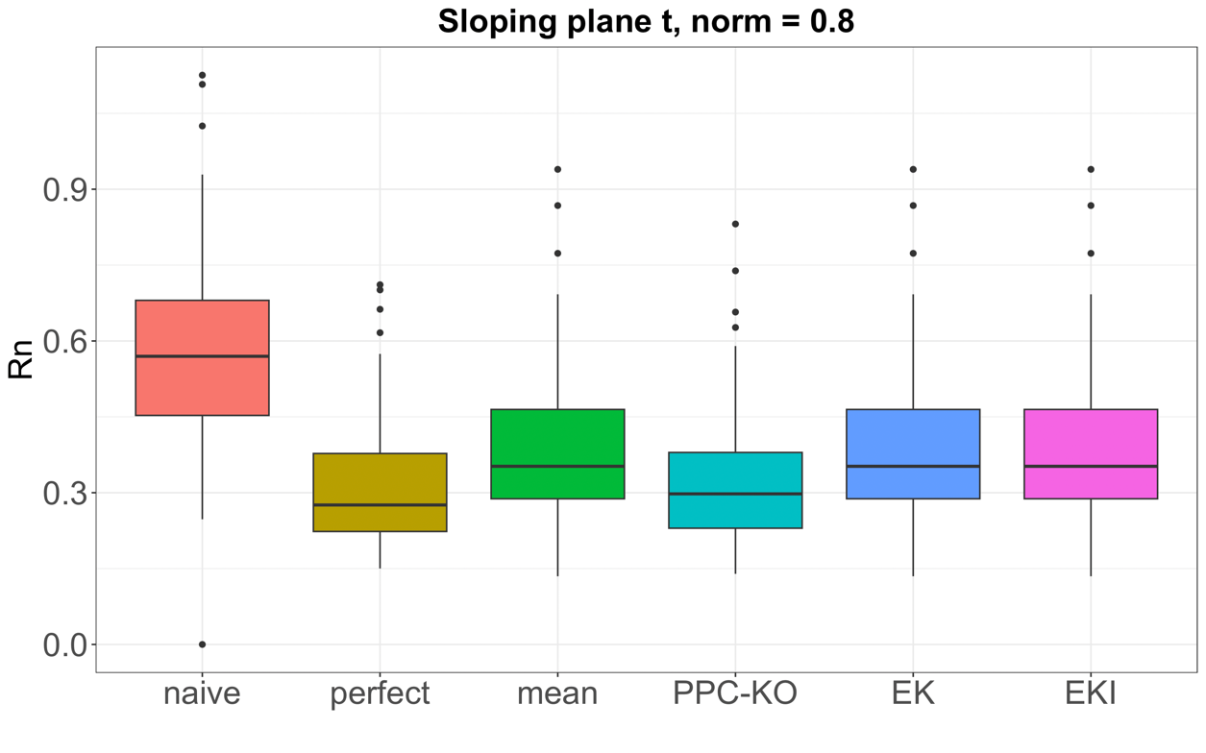

* N=100, sloping plane s

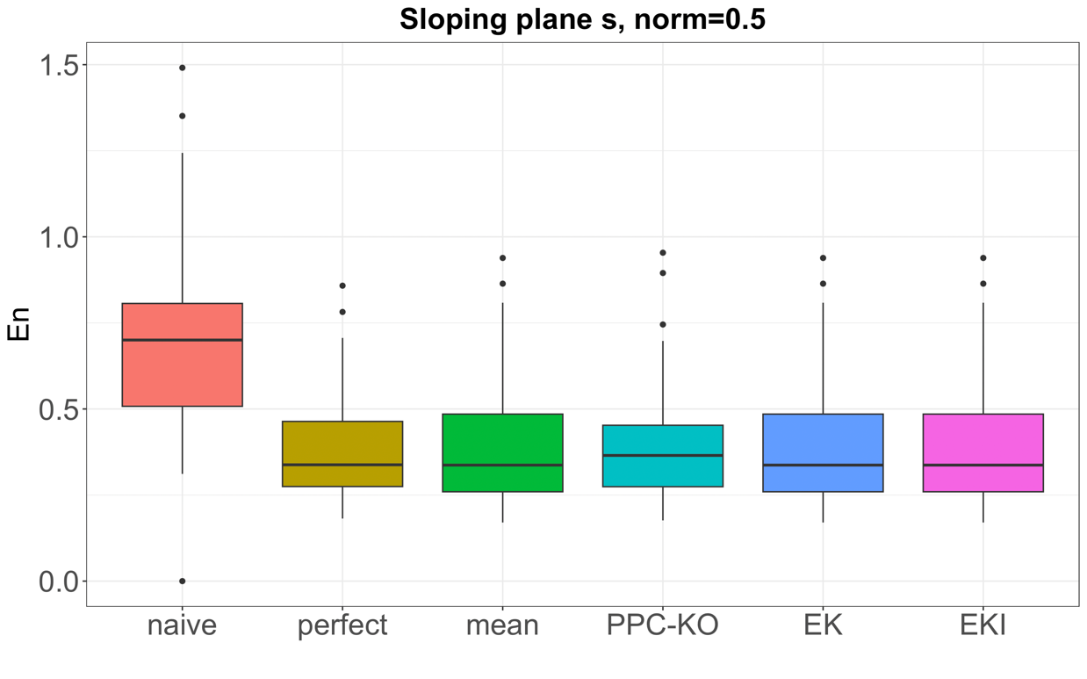

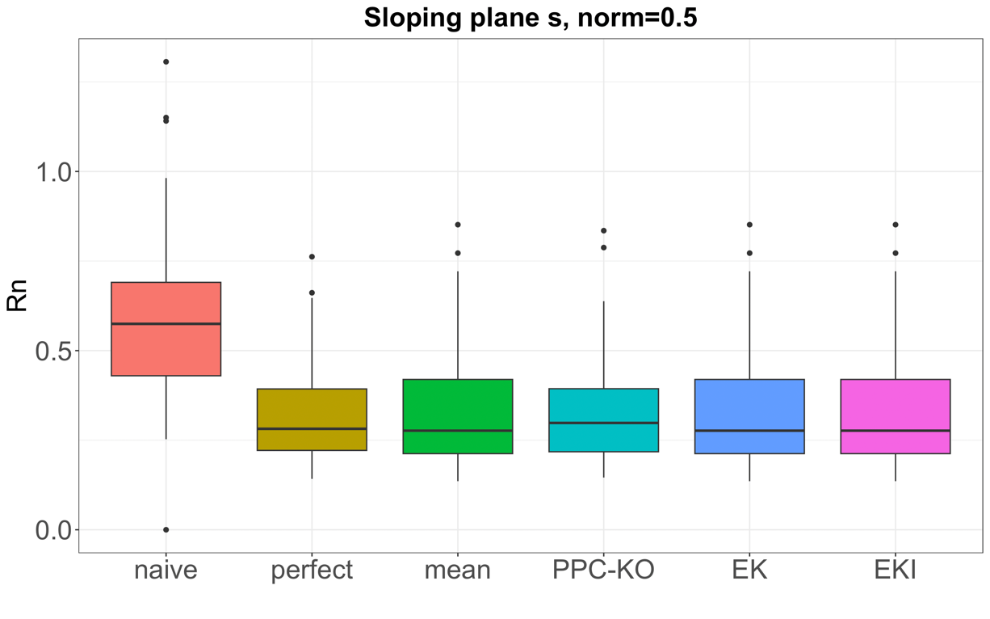

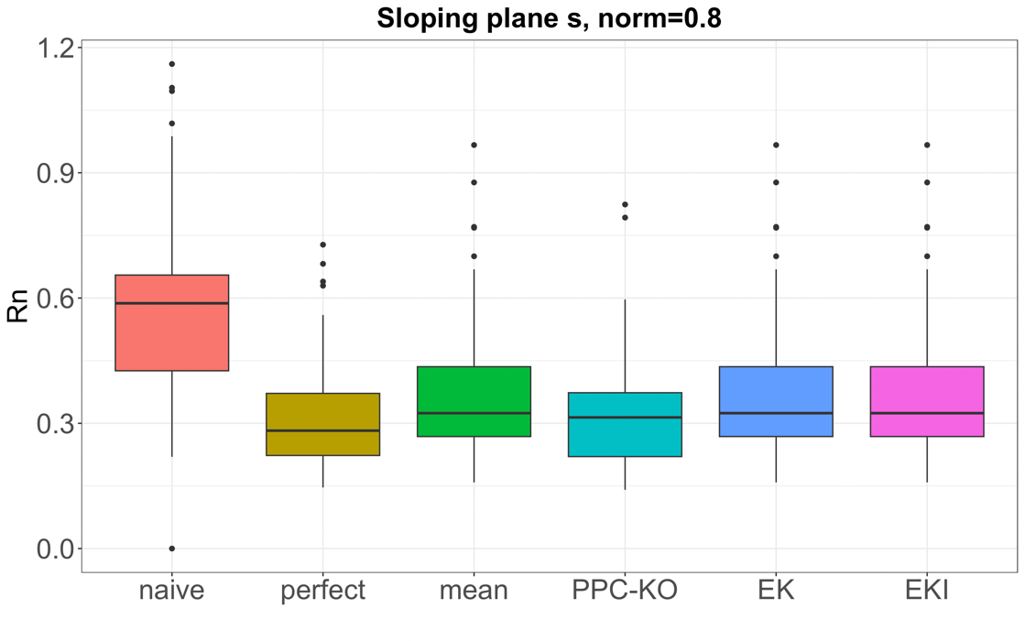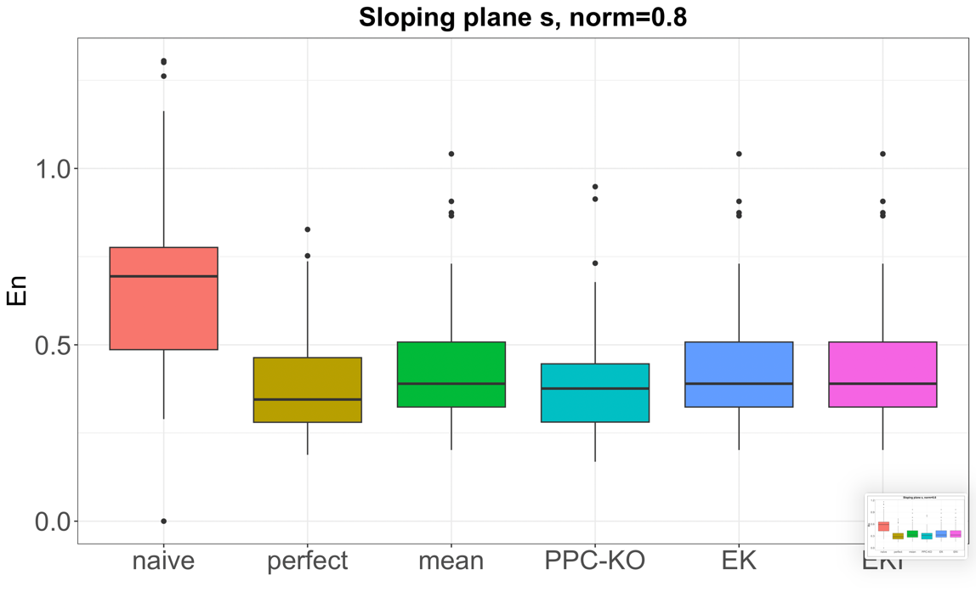

* N=100, identity

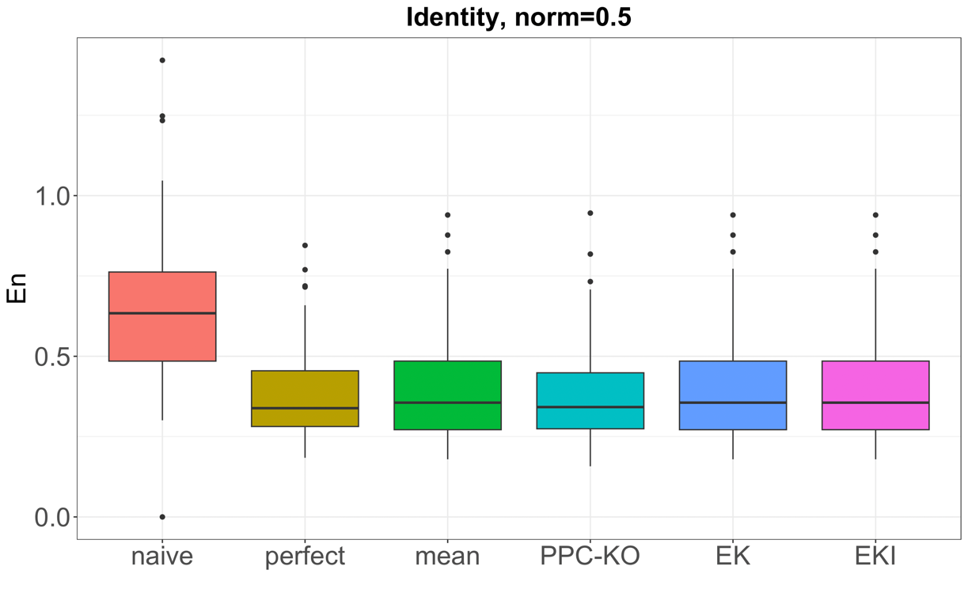

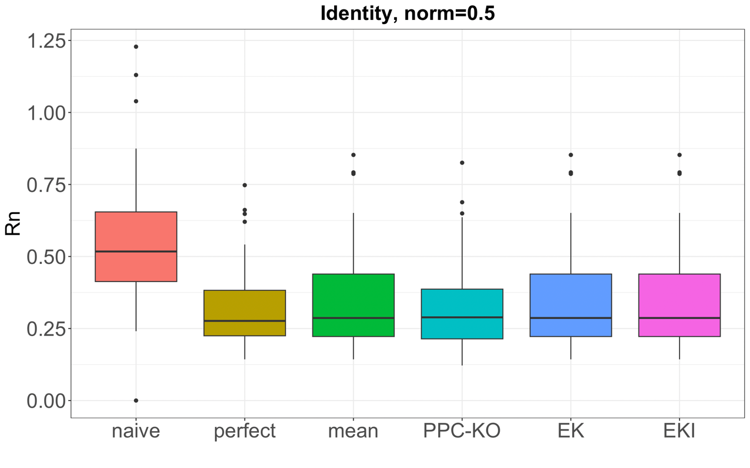

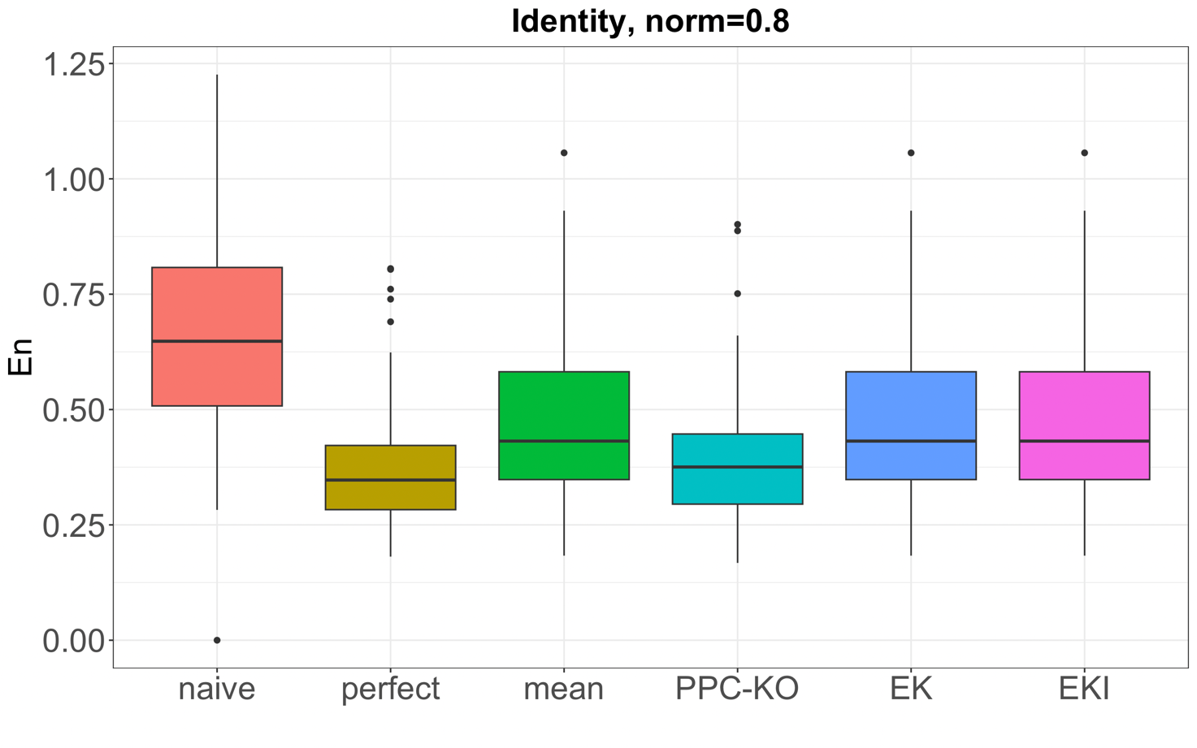

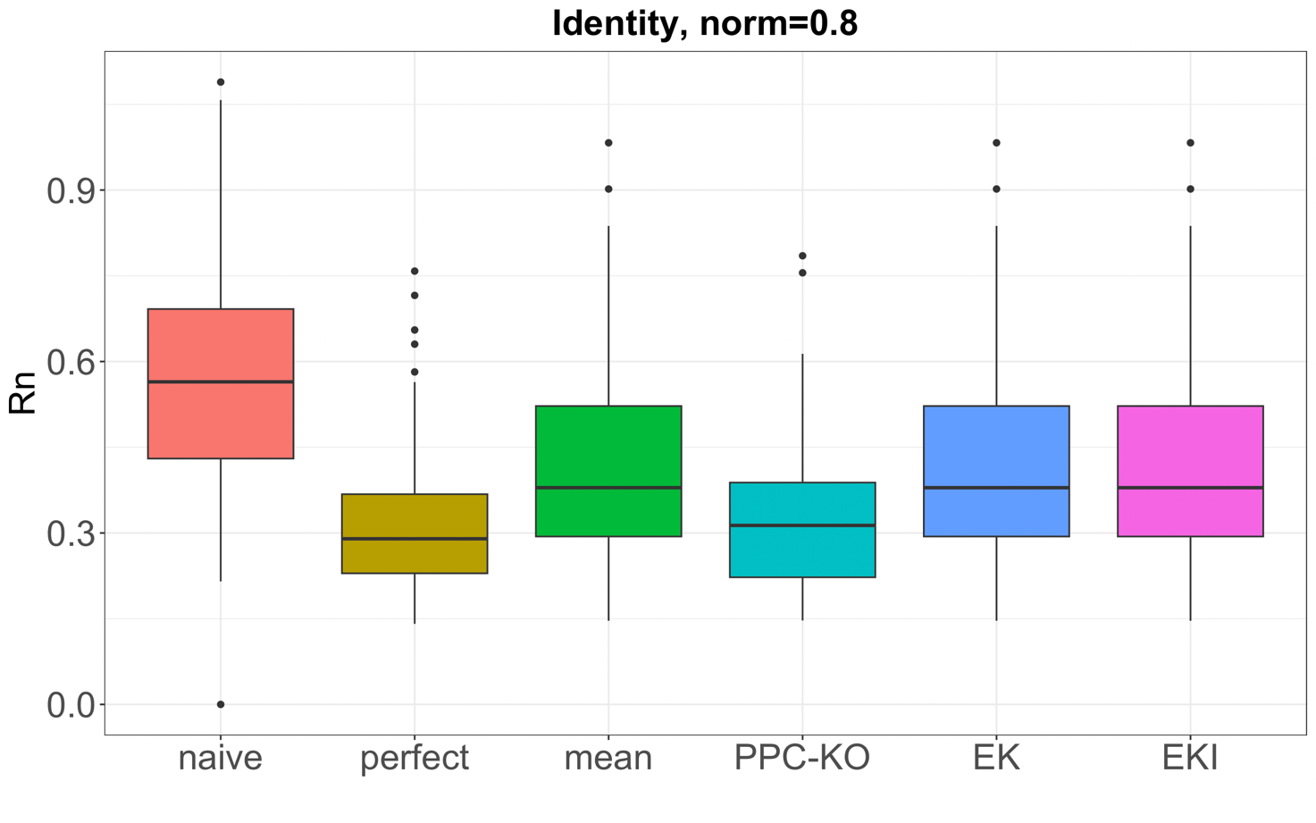

* N=100, gaussian

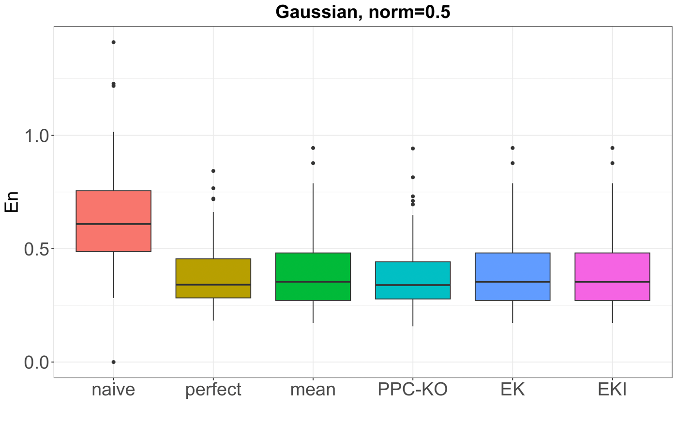

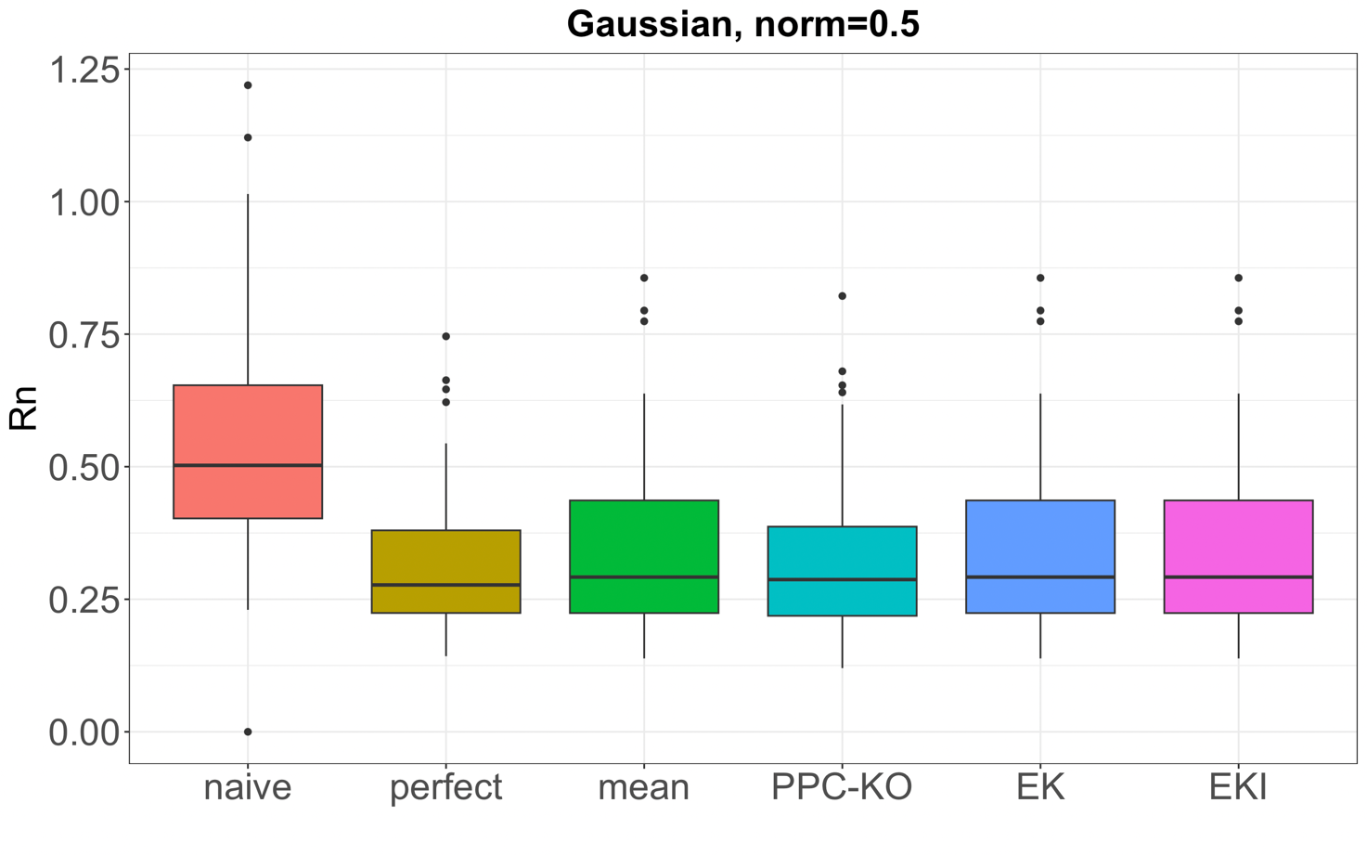

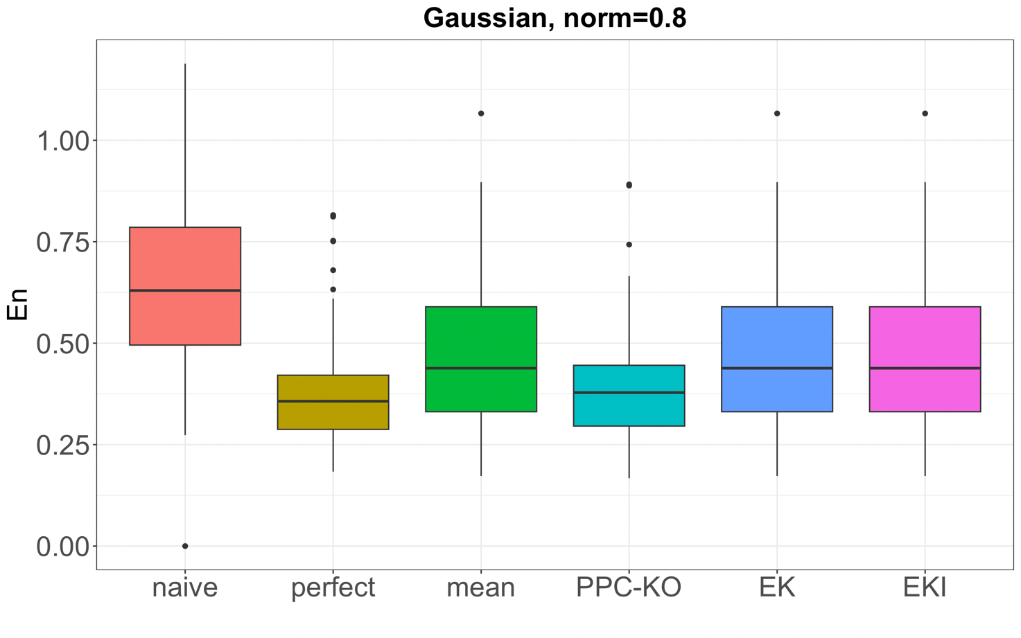

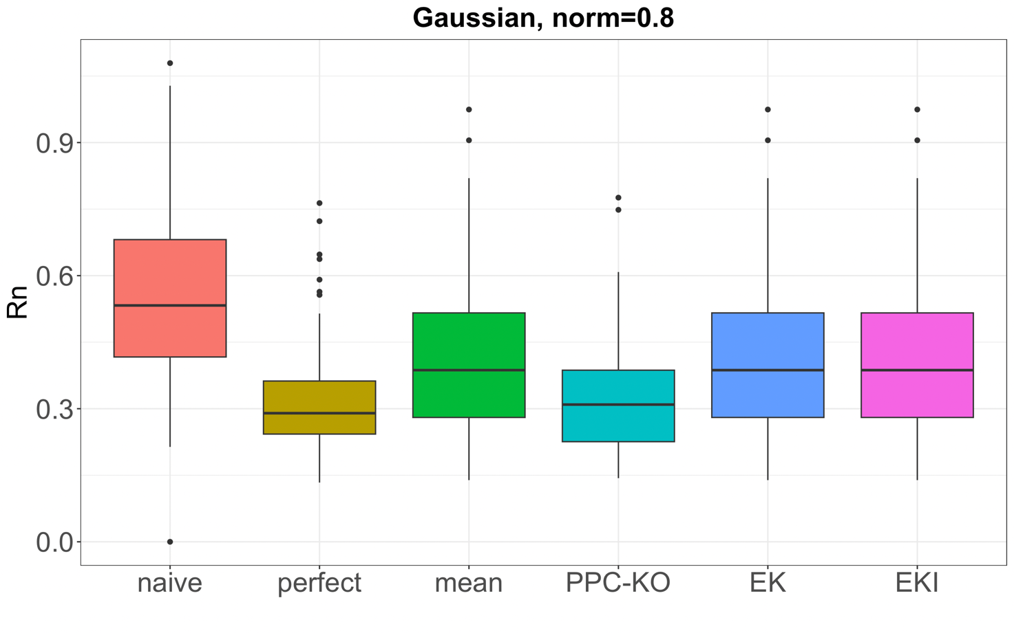

Taking from the functional element at time 51 up to 56: plot of the true trajectory and of the predicted one